**EX:10A**

**DATE: 24/09/24**

**Customized ping command to test the server connectivity**

### AIM: to ping command to test the server connectivity

from os import system print('1. Ping Google') print('2. Ping Yahoo') print('3. Ping custom URL') while True:

key = int(input('Input your choice: ')) if key == 1:

system("ping [www.google.com")](http://www.google.com/) elif key == 2:

system("ping [www.yahoo.com")](http://www.yahoo.com/) elif key == 3:

url = input('Enter URL: ') system("ping " + url)

else:

print("Invalid Option!")

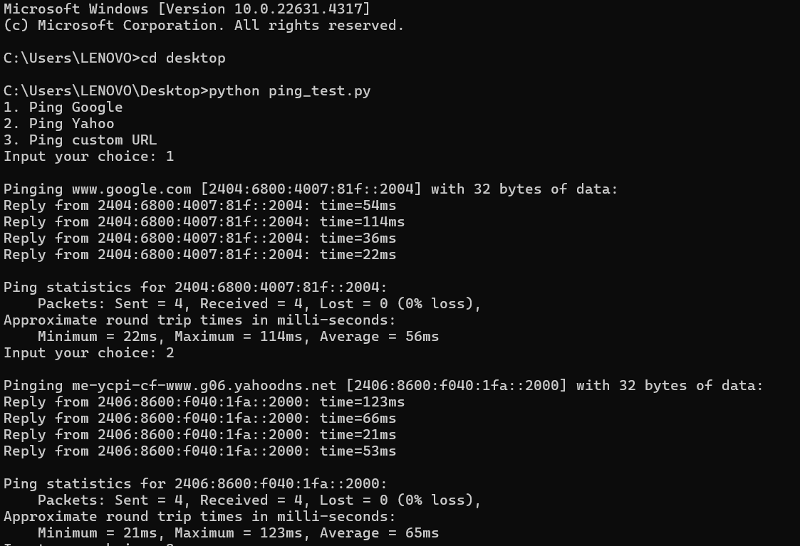

**RESULT:** server connectivity has been tested using ping command